**Initial Analysis**

Tomer Benish

Gal Granot

Calibration stage:

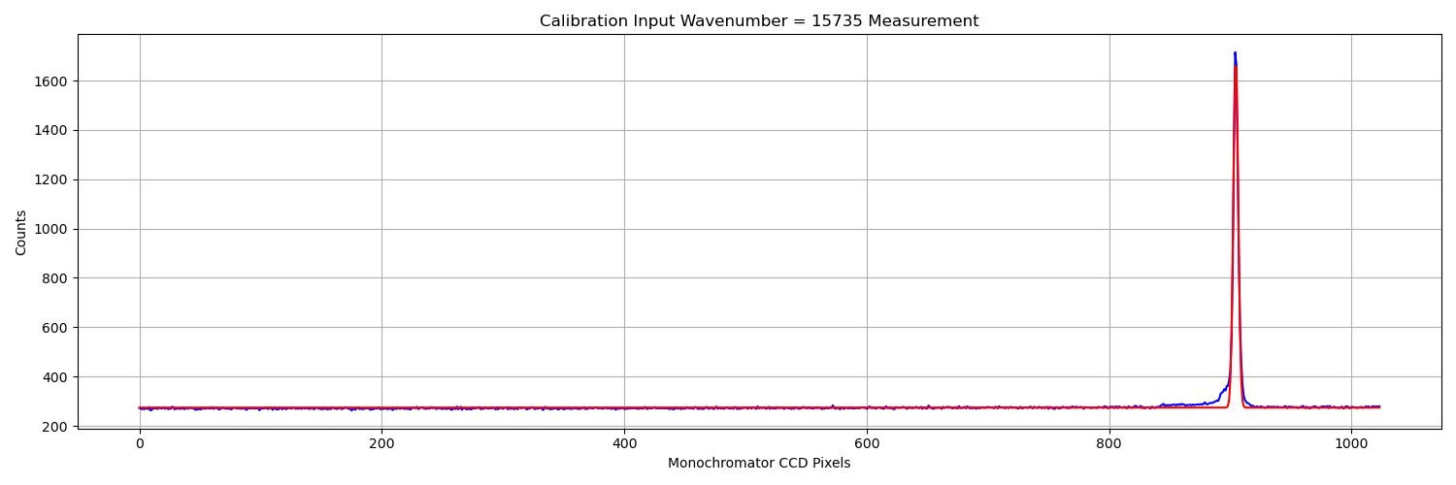

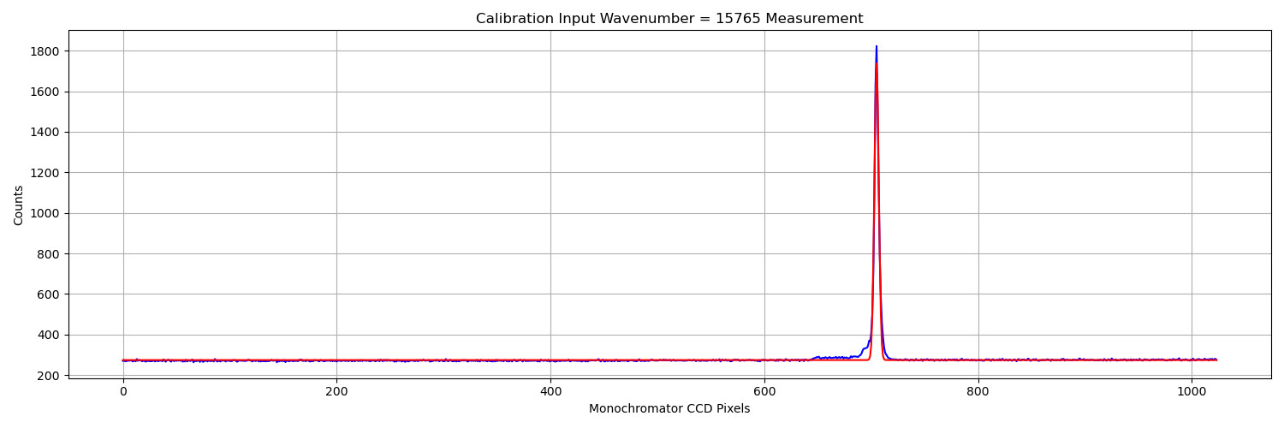

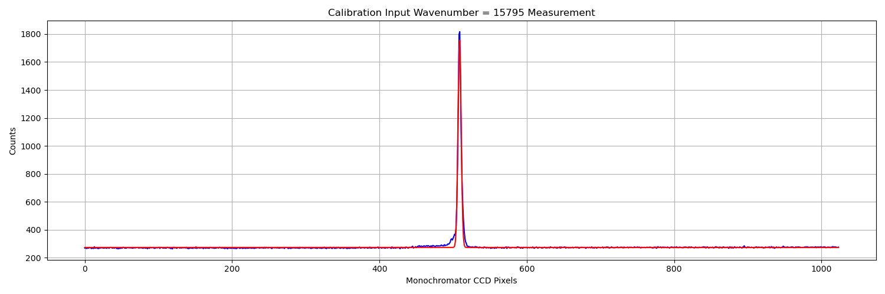

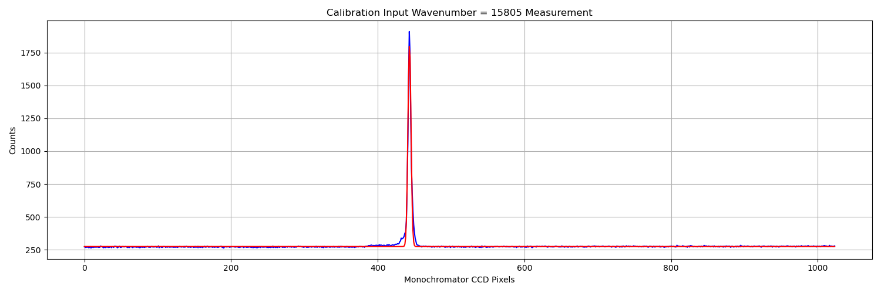

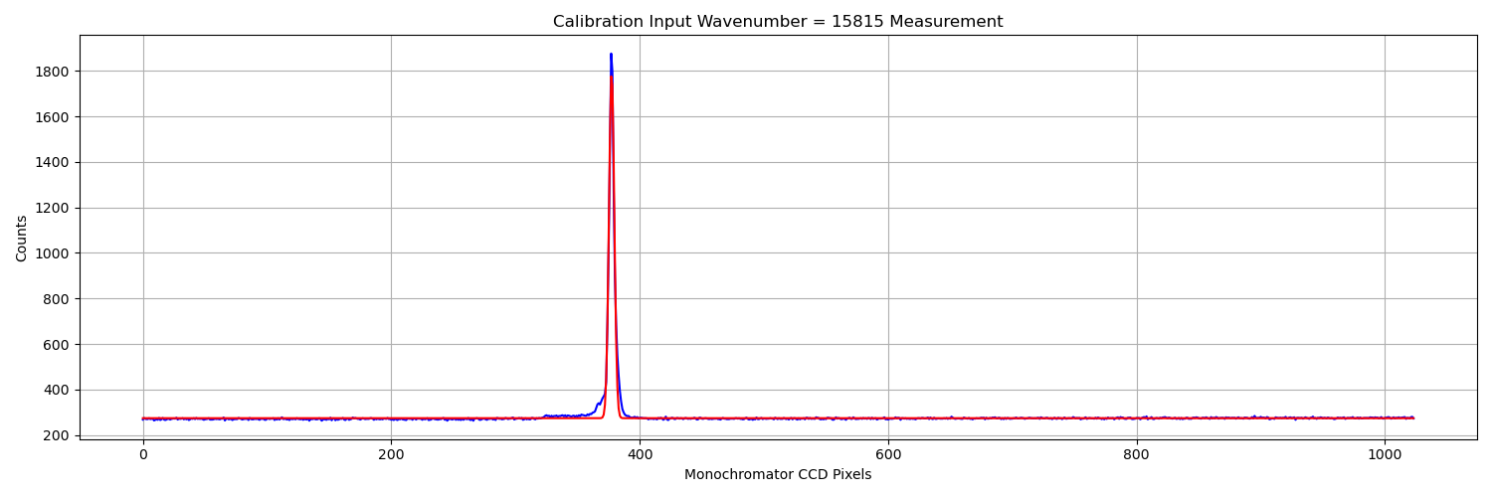

Notice in the following image that only the leftmost part of the pixels are shown (graph was truncated at measurements). The values are still very much consistent with the way this has been organized so far.

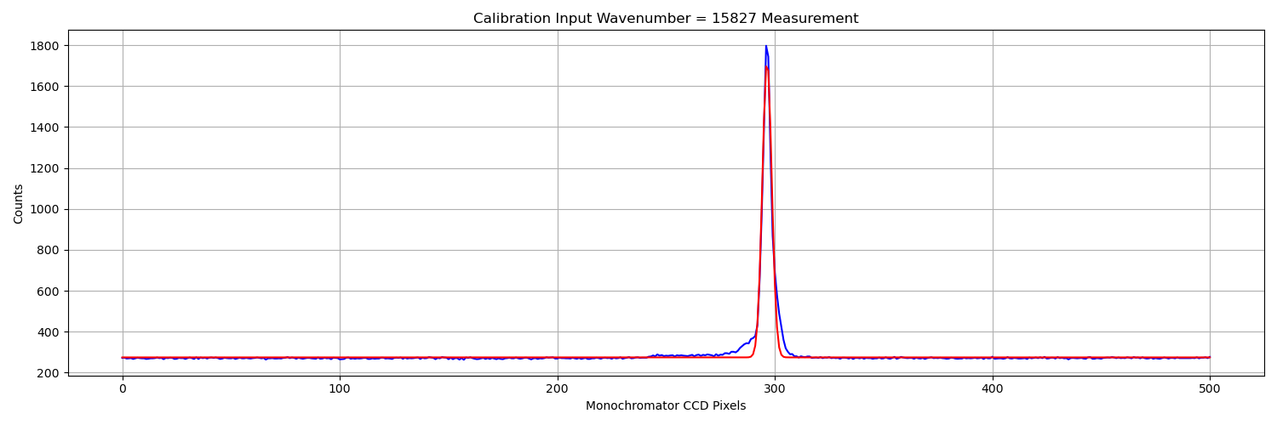

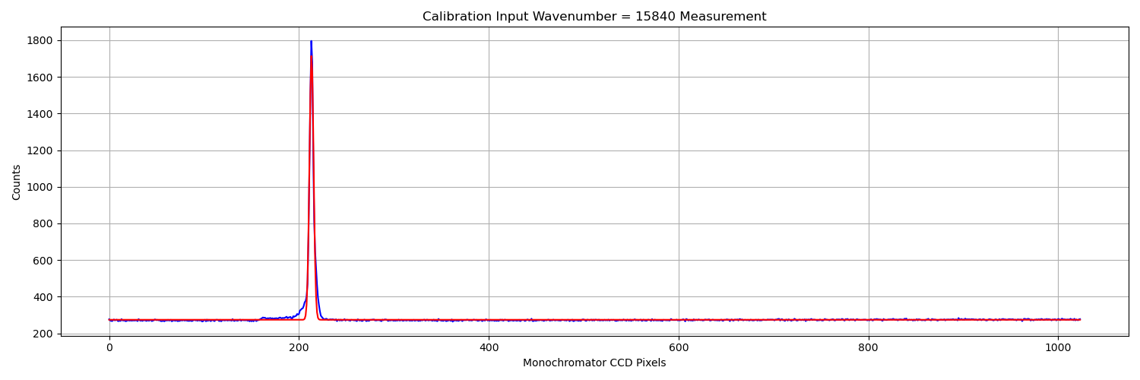

Fit of calibration measurements:

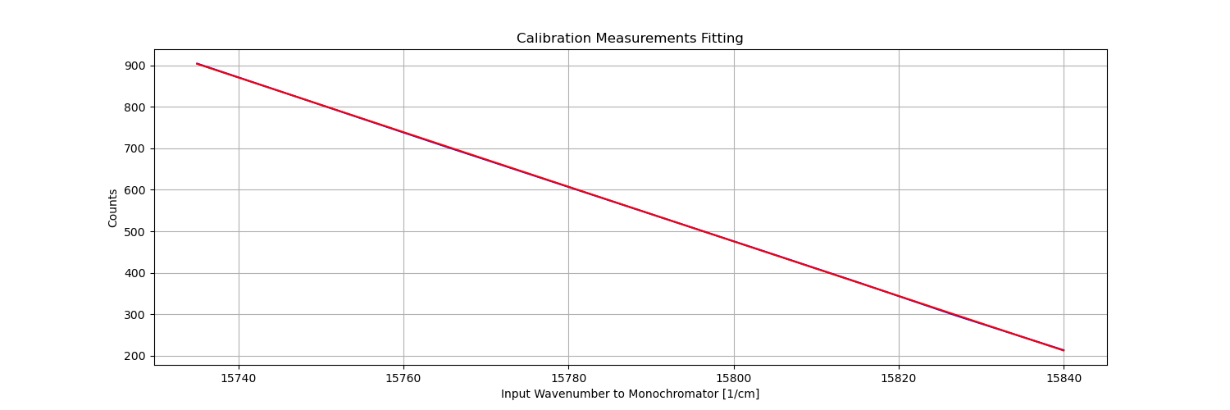

The reason you don’t see the original graph (blue) as well as the fit (red) is because the fit is so good they are nearly identical.

You can see this as well in the difference between the two:  
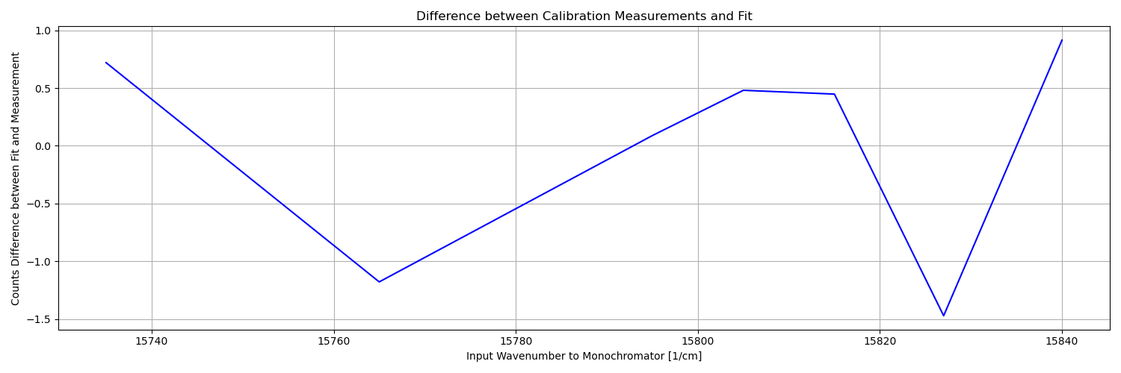

Notice the order of magnitude of the calibration fit error – it’s two orders of magnitude less than the count values we had in the measurements. Nice!

From the calibration stage we concluded that there is an offset of 512 – 325 = 187 pixels (325 is the pixel where the excitation wavenumber is supposed to be measured, as was retrieved from the linear fit), and the calculation to find out what the wavenumber of each pixel is:

Where is the

Notice that the laser’s excitation was taken into account in the pixel calibration calculation, and in the final wavenumber calculation in that the central pixel (512) is supposed to be correlated to the excitation wavenumber, and the difference between where the peak is and where it is supposed to be is where we receive the offset of 186 pixels.

Measurement fit Stage:

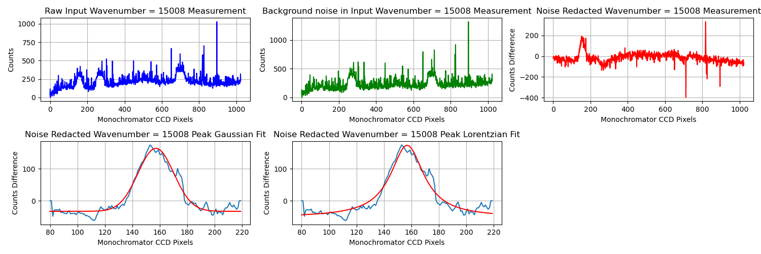

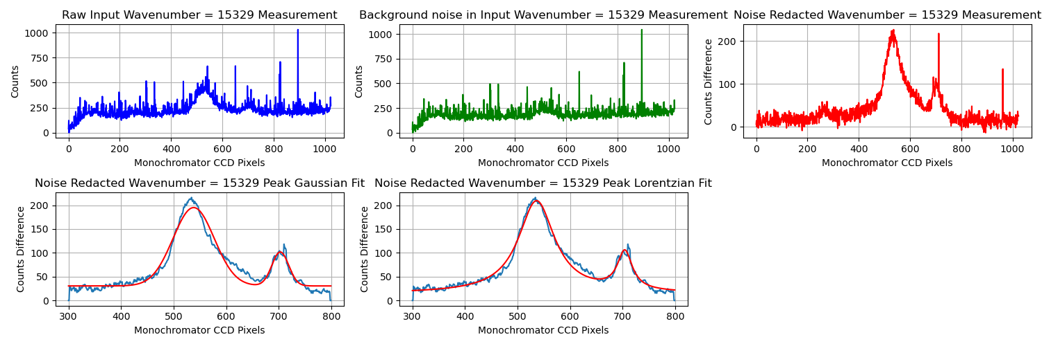

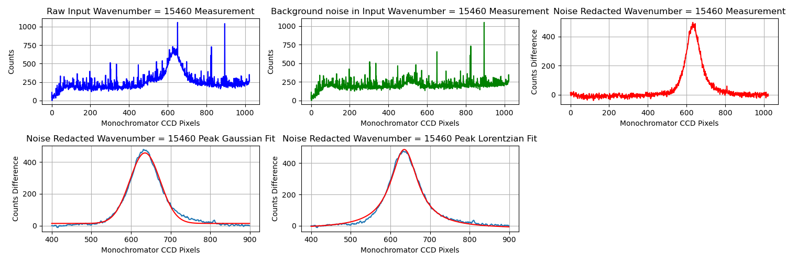

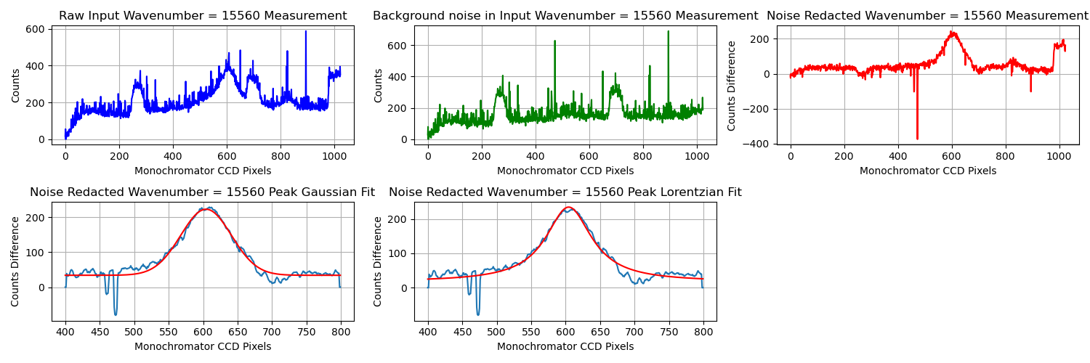

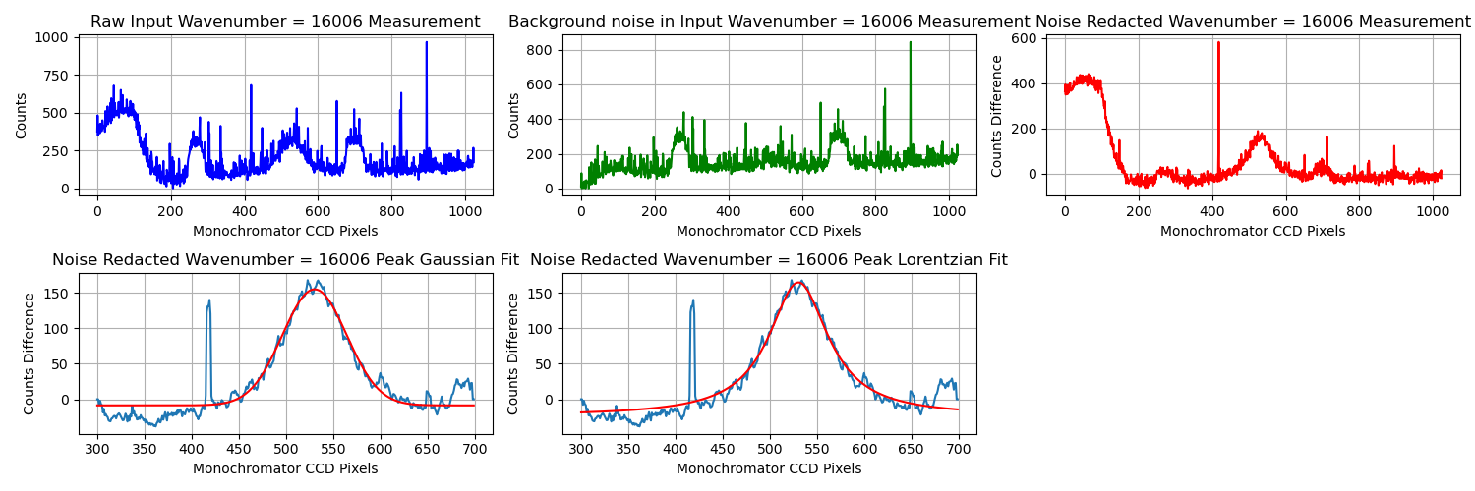

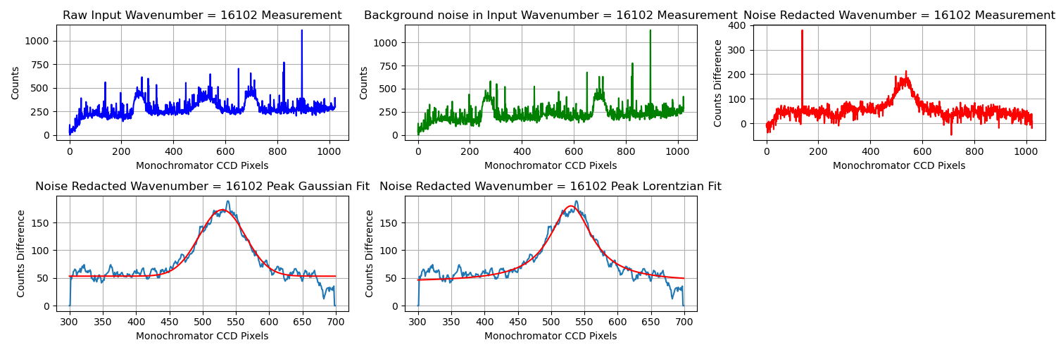

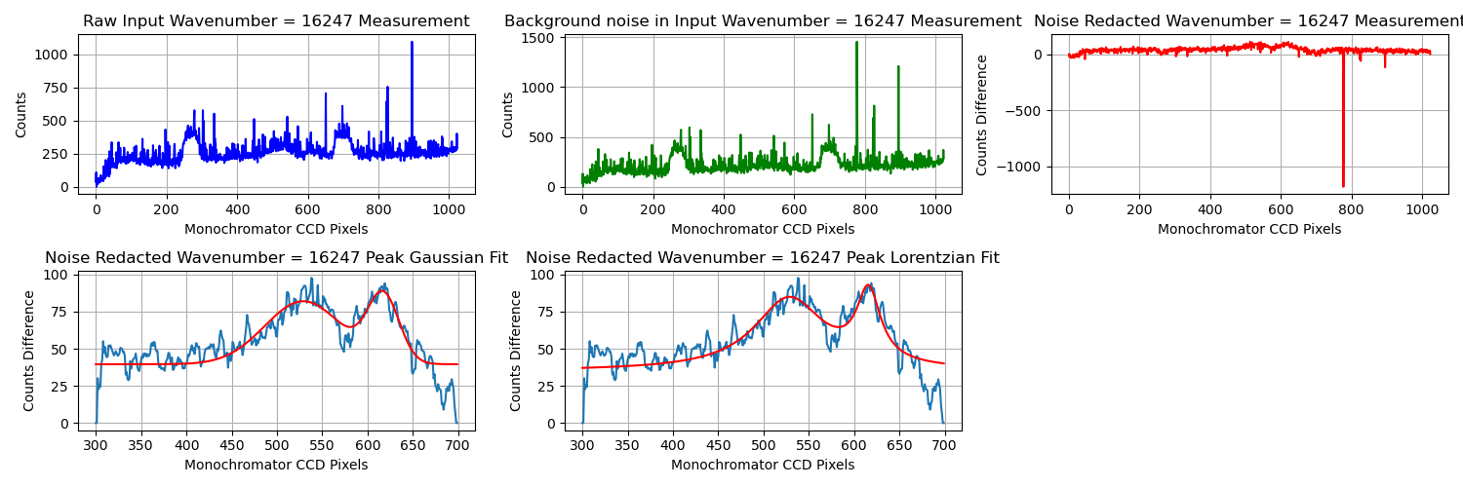

Final Stage: Calculating the frequency vector, and finding exactly where all the peaks are on that vector:

And plotting:

